RFLTools

Lesson 3: Drawing/Designing Barrier (BC MoTI)

This lesson will be short and sweet. The scenario is you have a Civil 3D surface and are looking for a path at a fixed grade traversing the surface.

This issue came up for me recently with a conceptual route planning exercise I was involved with in Kitimat BC. The terrain was extremely difficult but we needed to find road alignment to get from one point to another in the most efficient manor.

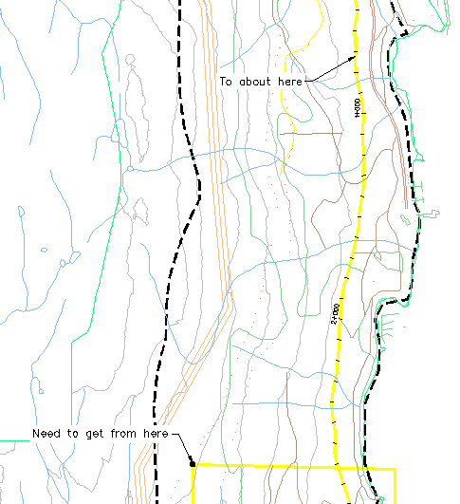

To assist with this I have created a command **C:PGRADE** which will draw a polyline such that the point-to-point grade is a preset value. It does this by dynamically cutting a cross section perpendicular to the current tangent (from the previous point to the point defined by your current cursor position) and determining at what point on that cross section is at that desired grade.

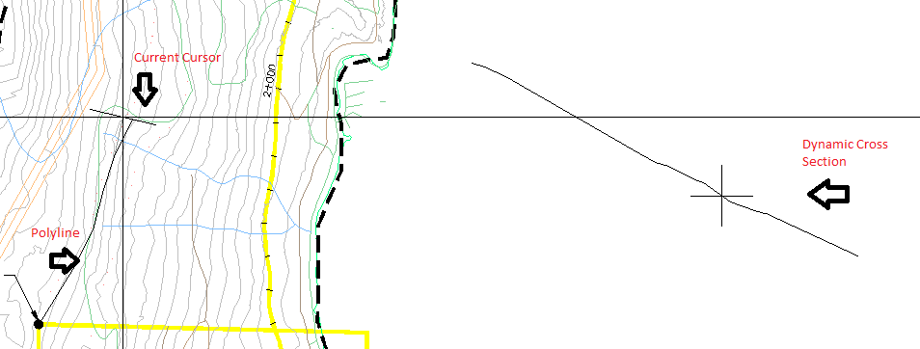

The polyline created will be your target alignment. As a designer you can follow as close or rough as you require but you have a high confidence that when you move forward to profile design you will be able to maintain the grade you previously specified.